CSE 581

**Lab 15: Error Handling**

**Purpose:**

Write an SP with an error handler.

**Deliverables:**

Multiple screenshots, as described through the lab.

Scripts that you used to carry out the actions.

**Steps:**

1. Create a stored procedure: The SP should accept 2 parameters (let’s say A and B) and return the result of A divided by B. The SP should do error handling[1], and if an error occurs, it should print out *“An error has occurred”* and ***return*** -1 as a result. Provide a **screenshot** of SP creation.

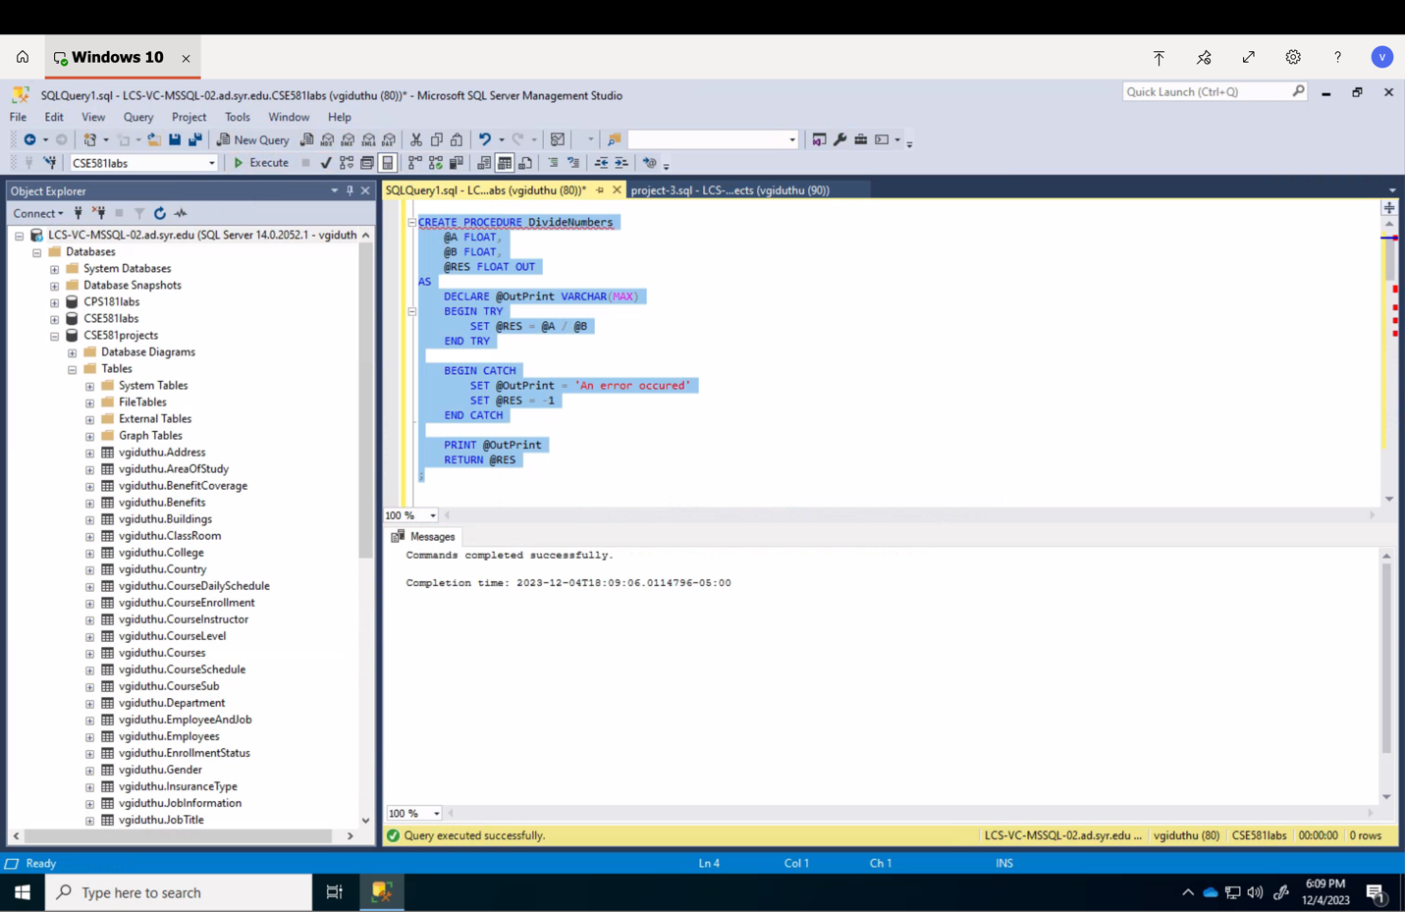

1. Execute the SP with input A = 10, B = 2. Provide a **screenshot** of execution, showing the result as well as error message, if any.

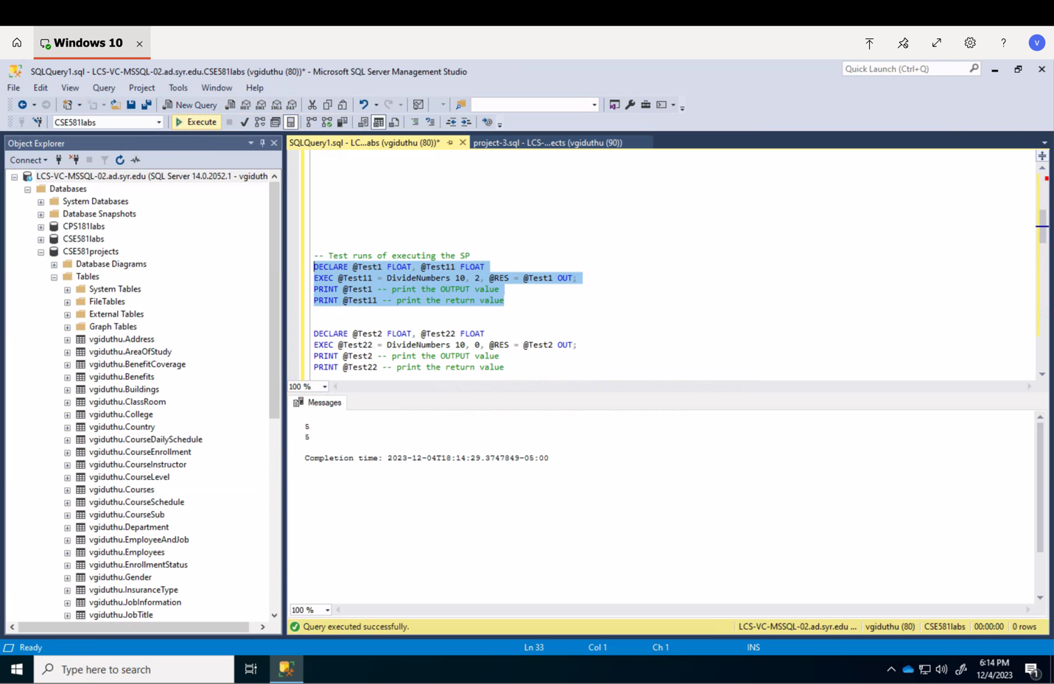

1. Execute the SP with input A = 10, B = 0. Provide a **screenshot** of execution, showing the result as well as error message, if any.

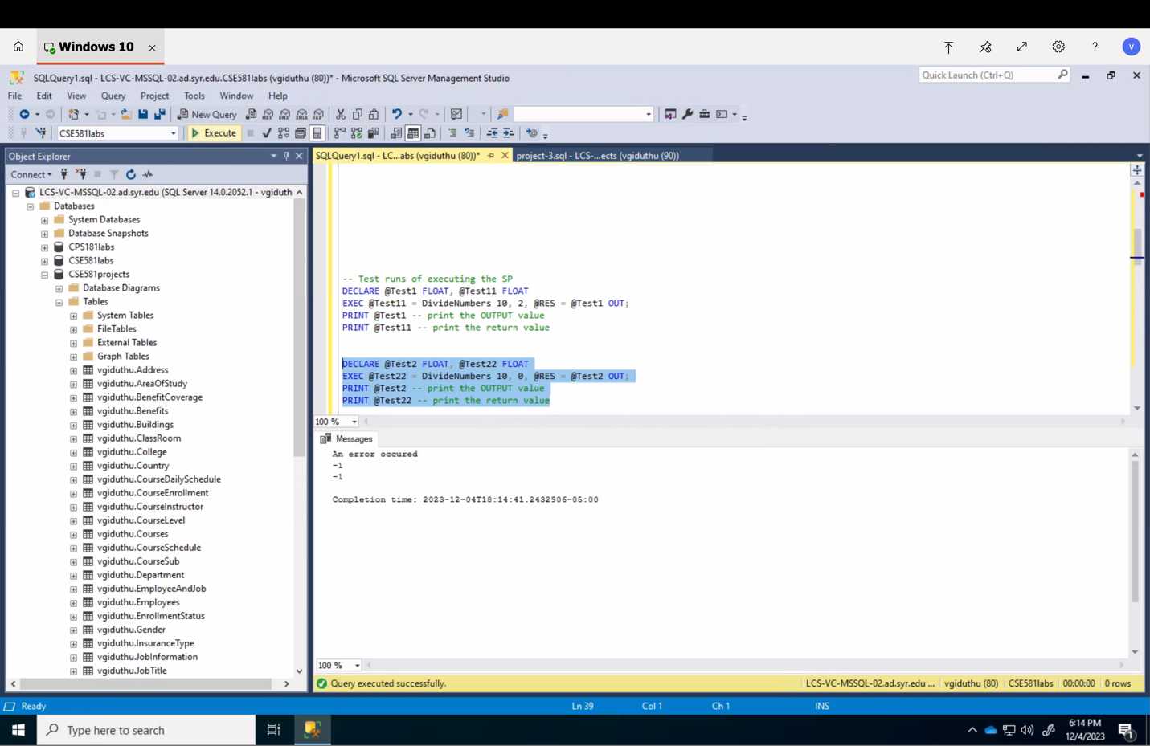

1. I would recommend using the TRY/CATCH block